3rd Kuhmo-Nectar
Summer School and Conference

Transport and Urban Economics

VU University Amsterdam
30 June – 4 July, 2008

PROGRAMME

Organized and sponsored by:
VU University, Tinbergen Institute, TRANSUMO, DVS Centre for Navigation and Transport, NECTAR

Welcome
It is a great pleasure for us to welcome you to Amsterdam for the Kuhmo Nectar Summer School and Conference, which are this year hosted by the Department of Spatial Economics of the VU University Amsterdam.

This edition will be the third in a sequence that started in Finland in 2006, and Urbino in 2007. We will do our best to come close to the standards set by these meetings, seeking a combination of inspiring lectures, innovative research papers, and lively discussions, all in a pleasant and informal atmosphere. Quite a challenge indeed!

We thank our sponsors, without whom this meeting would not have been possible: DVS Rijkswaterstaat, Transumo, Tinbergen Institute, VU University and Nectar.

We wish you all an inspiring meeting!

The Local Organizing Committee
Erik Verhoef
Hadewijch van Delft
Esko Niskanen
Edoardo Marcucci
Venue
The summer school and conference are held in the Vrije Universiteit (VU), Main Building, De Boelelaan 1105, Amsterdam.

How to get there
The VU is well accessible by local public transport. From the city centre, you can take:
- Tram 5, direction Amstelveen/Binnenhof. The stop “De Boelelaan/VU” is next to the main building. It takes around 25 minutes from Amsterdam Central Station.
- Sneltram 51 (combined metro/express tram), direction Amstelveen/Westwijk. The stop “De Boelelaan/VU” is next to the main building. It takes around 16 minutes from Amsterdam Central Station.
- Tram 16 and 24, direction VU Medisch Centrum. The stop “VU Medisch Centrum” is in front of the Vrije Universiteit’s Hospital, which is next to the university’s main building (a five minutes walk). It takes around 20 minutes from Amsterdam Central Station.
Your hotel service desk can advise you about the best connection from your hotel.

When arriving directly from Schiphol Airport, you can take a direct train to Amsterdam Zuid WTC, and either walk to the main building (5-10 minutes) or use tram 5 or sneltram 51 (one stop, same directions as above).

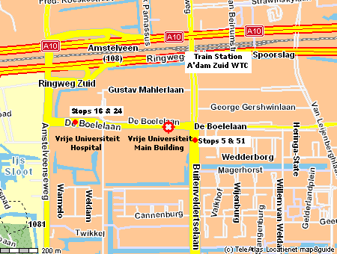
Registration
Monday 30 June from 08.00 to 09.00 and on Thursday 3 July from 08.30 to 09.30. Outside these hours, please contact the Conference Secretariat, Mrs Hadewijch van Delft, personally. Registration will take place on the second floor, close to the rooms where the summer school lectures and conference sessions are held.

Rooms
All lectures and sessions are held on the second floor, in rooms 2A-02, 2A-05 and 2A-06.

Lunches will be held in the university restaurant, on the ground floor level.

Coffee breaks are held in an area close to the lectures and session rooms.

Public transport
The conference bag that you receive upon registration contains a public transport pass. Please stamp this pass the first time you use it (in the yellow stamp machine inside the tram, on the platform, or with the bus driver). After stamping, you can make unlimited use of trams, buses, metro’s and night buses in the city of Amsterdam for a period of 48 (conference) or 72 (summer school) hours.

Presentation technology
A lap-top and beamer will be available in each room for presentations. Our default assumption is that you will use these for your PowerPoint presentation, which you can bring along on diskette, CD-ROM or USB memory device (risk averse individuals bring along at least two of these). To avoid the loss of time, hooking up of personal lap-tops is discouraged. Presenters are invited to the room 10 minutes prior to the start of the session, so that presentations can be copied onto the lap-top before the session starts. Please avoid the use of file names like kuhmonectar.ppt, as this may replace your colleagues’ presentations. If you wish to use traditional overhead slides, please inform us beforehand so that we can arrange an overhead projector. The computers will be ready for PowerPoint 2007 presentations (and earlier versions).

Chairs
Chairs are invited to come to the room 10 minutes prior to the start of the session. They introduce the session and the speakers, make sure that the time available is divided equally over the papers to be presented, and guide the discussion with the floor following the presentation. The conference programme identifies the chairs for individual sessions. In case a chair does not show up, the presenter of the last paper is expected to take over the role of chair.

Internet
Computers with an internet connection will be available for delegates in Room 3A-12 of the Main Building (on the third floor). The room will be open from Monday to Friday from 09.00 to 17.00. To get access to the network, a login name and password are required, which will be included in the conference bag that you receive upon registration. The number of available computers is finite. Etiquette stipulates that in case of a queue, a user will not keep a computer occupied for more than 30 minutes. In case of technical problems, please consult the ICT helpdesk in Room 3A-16.

Photocopying
Photocopying facilities are available during office hours in the basement of the University’s main building (below the main entrance). Copy cards can be purchased at the Main Building’s reception desk, immediately to the left of the main entrance when entering the building. A card valid for 100 copies costs € 5.

Committees

Local Organizing Committee
- Erik Verhoef, Vrije Universiteit Amsterdam, The Netherlands, chair
- Hadewijch van Delft, Vrije Universiteit Amsterdam, The Netherlands, congress secretariat
- Edoardo Marcucci, Università Roma Tre, Italy, NITEL, CIRIAF
- Esko Niskanen, STAResearch, Helsinki, Finland

Conference Scientific Committee
- Erik Verhoef, VU University Amsterdam, The Netherlands
- Edoardo Marcucci, Università Roma Tre, Italy, NITEL, CIRIAF
- Esko Niskanen, STAResearch, Helsinki, Finland
- Richard Arnott, UC Riverside, USA
- Alex Anas, State University of New York, Buffalo, USA
- Jan K Brueckner, University of California, Irvine, USA
- Francis Cheung, Transport Research Centre (AVV), Ministry of Transport, The Netherlands
- André de Palma, University of Cergy-Pontoise and ENPC, Paris, France, and adpC, Belgium
- Piet Rietveld, VU University Amsterdam, The Netherlands
- Kenneth Small, University of California, Irvine, USA
- Bernhard Wieland, Technical University of Dresden, Germany

Summer School Steering Committee
- Richard Arnott, UC Riverside, USA
- Edoardo Marcucci, Università Roma Tre, Italy, NITEL, CIRIAF
- Esko Niskanen, STAResearch, Helsinki, Finland
- Erik Verhoef, VU University Amsterdam, The Netherlands

Monday 30 June – Wednesday 2 July

SUMMER SCHOOL

VU University Main Building
Room 2A-05
Monday 30 June

GENERAL INTRODUCTION

09.00-10.30 Lecture 1
Urban transport demand modelling: state of the art
Kenneth Small

10.30-11.00 Coffee break

11.00-12.30 Lecture 2
Urban transport supply modelling: state of the art
Kenneth Small

12.30-13.30 Lunch break

13.30-15.00 Lecture 3
Static and dynamic equilibria and optima in urban transport
Richard Arnott

15.00-15.30 Coffee break

15.30-17.30 Lecture 4 and Tutorial
Discrete choice models: theory and application
Andre de Palma and Nathalie Picard

18.30 Dinner at ‘Het Blauwe Theehuis’ in the Vondelpark

Restaurant Het Blauwe Theehuis
Vondelpark 5
(www.blauwetheehuis.nl)

Route description from the VU University:
Take tram 5 direction Central Station
Get off at ‘Willemsparkweg’, 10 minutes walking (red line on the map)
Total travel time approximately 30 minutes

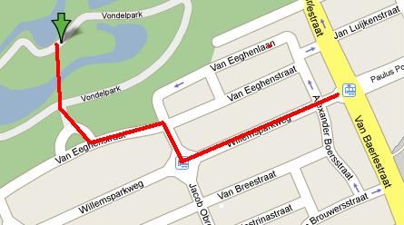

Tuesday 1 July

URBAN TRANSPORT ANALYSIS

09.00-10.30 Lecture 5
Travel time unreliability and valuation
Mogens Fosgerau

10.30-11.00 Coffee break

11.00-12.30 Lecture 6
Transport and urban land use: conceptual issues
Richard Arnott

12.30-13.30 Lunch break

13.30-15.00 Lecture 7
Applied integrated transport and land use modeling
Alex Anas

15.00-15.30 Coffee break

15.30-17.00 Lecture 8
Transport nodes and urban development
Piet Rietveld

17.30-23.00 Dinner at IJmuiden Beach (www.paviljoenzeezicht.nl)
Bus leaves at 17.30 from the university in front of the main entrance
Arriving back at the VU around 23.00

Wednesday 2 July

URBAN TRANSPORT POLICIES: INVESTMENT AND PRICING

09.00-10.30 Lecture 9
Hub airports and economic development
Jan Brueckner

10.30-11.00 Coffee break

11.00-12.30 Lecture 10
Pricing and capacity choice in urban transport
Erik Verhoef

12.30-13.30 Lunch break

13.30-15.00 Lecture 11
Congestion management in aviation
Jan Brueckner

15.00-15.30 Coffee break

15.30-17.00 Lecture 12
Second-best public and private provision of tolled roads
Erik Verhoef

17.30-18.30 Exam

18.30 Dinner at ‘IJ-kantine’

Restaurant IJ-Kantine
MT Ondinaweg 15-17
(www.ijkantine.nl)

Route description from the VU University:
Take tram 5 or 51 to ’Central Station’
Take (free) ferry to ‘NDSM-werf’ (red line on the map), boarding behind Central Station on De Ruijterkade; so take the back entrance of the station. It departs every 15 minutes (18.30, 18.45, etc.). The restaurant is located just near the quay.
Total travel time approximately 40 minutes

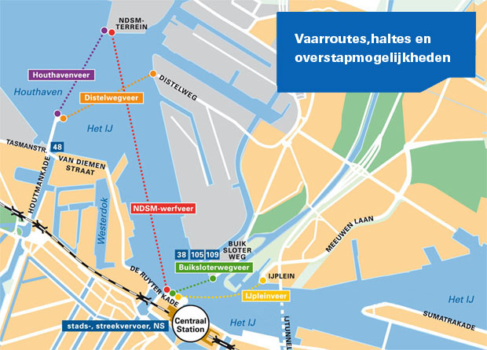

Thursday 3 July - Friday 4 July

NECTAR CONFERENCE

VU University Main Building
Rooms 2A-02, 2A-05, 2A-06
09.30-10.30 Opening and key note lecture
- Jan Brueckner TBA

10.30-11.00 Coffee break

11.00-12.30 Room 2A-02 Health and Safety

Chair: Esko Niskanen
- Shanmuganandan Samarajalingam TITEL??
- Gila Albert, Tomer Toledo and Shalom Hakkert Monetary Evaluation of Safety Measures

11.00-12.30 Room 2A-05 Investment and Financing I: Theory

Chair: Edoardo Marcucci
- Olga Ivanova Formulation of simultaneous car and public transport network equilibrium in the form of mixed complementarity problem in the context of bi-level programming
- Eran Leck, Shlomo Bekhor, Daniel Gat Equity and Efficiency Impacts of Transportation Improvements in a System of Cities Characterized by a Core-Periphery Structure
- Andre de Palma, Stef Proost, Saskia van der Loo Financing constraints in the bottleneck model

11.00-12.30 Room 2A-06 Public Transport

Chair: Frances Chueng
- Vincent van den Berg, Eric Kroes, Erik Verhoef Choice of Train Ticket: a Study on Dutch travellers
- Salvatore Amoroso, Marco Migliore, Mario Catalano, Fabio Galatioto A demand-based methodology for planning the bus network of a small-medium sized town
- Matthew G. Karlaftis Ownership and Competition in European Public Transport: A dynamic ARCH Stochastic Frontier Efficiency Assessment
- J.C. van Ham and J.H.J. Baggen Reorganizing public transport in the Netherlands: the future of urban transport

12.30-13.30 Lunch break

13.30-15.00 Room 2A-02 Pay as you drive

Chair: Jasper Knockaert
- J.W.Bolderdijk, E.M.Steg Acceptability and Adoption of Pay-As-You-Drive Vehicle Insurance: the Role of Privacy Concerns
- J. Zantema, D.H. van Amelsfort, P.H.L. Bovy, M.C.J. Bliemer Pay-As-You-Drive (PAYD): A case study into the safety and accessibility effects of PAYD strategies

13.30-15.00 Room 2A-05 Investment and Financing II: Case Studies

Chair: Ken Small

Petros Ieronomonachou, Stephen Potter, James Warren The Olympic legacy dilemma - designing transport systems for beyond the Games
- Isabella Lami, Elena Donellini Potential roles of project financing in transforming the port of Genoa
- Mark Koetse, Jan Rouwendal Transport and Welfare Consequences of Infrastructure Investment: A Case Study for the Betuweroute

13.30-15.00 Room 2A-06: Parking and Car Ownership

Chair: Richard Arnott
- Karel Spitaels, Sven Maerivoet An empirical agent-based model of parking behaviour
- Jan Rouwendal Car use, car ownership, and quality choice

15.00-15.30 Coffee break

15.30-17.00 Room 2A-02 Spitsmijden

Chair: Jasper Knockaert
- M.C.J. Bliemer, D.H. van Amelsfort Rewarding instead of charging road users: a model case study investigating effects on traffic conditions
- Dick Ettema, Jasper Knockaert, Erik Verhoef Using Incentives as a Traffic Management Tool
- Jan Rouwendal, Erik Verhoef and Jasper Knockaert Congestion in the Dutch Randstad

15.30-17.00 Room 2A-05 Investment and Financing III: Theory

Chair: Erik Verhoef
- Datuk Ary Adriansyah Samsura An Introduction to Value Capturing Methods for Transportation Infrastructure Development: A New Institutional Economics Approach
- Noemi Patumi and Giuliano Sparacino Public Private Partnership for urban mobility
- Kenneth A. Small and Chen Ng Tradeoffs among Free-flow Speed, Capacity, Cost, and Environmental Footprint in Highway Design

15.30-17.00 Room 2A-06 Freight

Chair: Piet Rietveld
- Oleg Poklad Scheduling System for the Regulation of Long-haul Service with Use of Road Trains.
- Olaf Jonkeren, Erhan Demirel, Jos van Ommeren, Piet Rietveld Imbalance in trade flows as a determinant of transport prices in a spatial network
- E. Demirel, J. van Ommeren, P. Rietveld Water-Level Risk on the Rhine River

18.30 Dinner at Restaurant Het Tuynhuys

Restaurant Het Tuynhuys
Reguliersdwarsstraat 28
(www.tuynhuys.nl)

Route description from the VU University:
Take tram 5 direction Central Station
Get off at ‘Koningsplein’
Walk 1 minute to restaurant (red line on the map)
Total travel time approximately 20 minutes

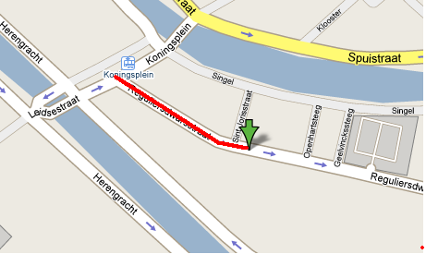

09.00-10.30 Room 2A-05 Road Pricing I: Modelling

Chair: Richard Arnott
- Siriphong Lawphongpanich, Yafeng Yin Exact and Approximate Pareto-Improving Congestion Tolls
- Andrew Koh, Simon Shepherd Tolling, Capacity Selection and Equilibrium Problems with Equilibrium Constraints
- Bruno De Borger Optimal congestion pricing in a wage bargaining model

09.00-10.30 Room 2A-06 Heterogenity

Chair: Mogens Fosgerau
- Gila Albert and Naomi Zeitouni Tolls, congestion, and utility maximization with heterogeneous road users
- Pedro Cantos-Sánchez, Rafael Moner-Colonques, José J. empere-Monerris, Óscar Álvarez San-Jaime Viability of a New Road Infrastructure with Heterogeneous Users in Madrid Access
- Elenna R. Dugundji Socio-dynamic discrete choice on networks

10.30-11.00 Coffee break

11.00-12.30 Room 2A-02 Land Use and Transport I: Household Behaviour

Chair: Alex Anas
- Iragaël JOLY Impact of the residential location on the relation between travel time and activities duration
- Guillaume POUYANNE Urban form and Daily Mobility. Methodological aspects and empirical study in the case of Bordeaux (France)
- Mogens Fosgerau, Jos Van Ommeren The workers' marginal costs of commuting

11.00-12.30 Room 2A-05 Road Pricing II: Design and Impacts

Chair: Frances Chueng
- Bulteau Julie Modelling urban toll associated to a modal policy: objective to reduce external effects of cars
- Borja Beltran, Stefano Carrese Environmental Equilibrium Assignment
- Marcucci, Danielis, Rotaris The Ecopass system in Milan: theoretical reflections an preliminary evaluations

11.00-12.30 Room 2A-06 Aviation I: Pricing

Chair: Eric Pels
- Leonardo J. Basso and Anming Zhang On the relationship between airport pricing models
- Joseph Daniel, Katherine Thomas Harback Pricing the Major Hub Airports
- Matteo Ignaccolo, Giuseppe Inturri, Elena Rubulotta A marginal cost pricing model for optimal airport charging
- Jan K. Brueckner and Vivek Pai Technological Innovation in the Airline Industry: The Impact of Regional Jets

12.30-13.30 Lunch break

13.30-15.00 Room 2A-02 Land Use and Transport I: Firm Behaviour

Chair: Edoardo Marcucci
- Isabella Lami, Laurent Staffelbach The transformation of the Zurich central station: processes of urban renewal and regeneration
- Vincenzo Del Giudice; Pierfrancesco De Paola; Francesca Torrieri A random utility model for the location of real estate investment
- Marco Alderighi and Claudio Piga The Circular City with Heterogeneous Firms

13.30-15.00 Room 2A-05 Road Pricing III: Design and Impacts

Chair: Esko Niskanen
- James Warren, P Ieromonachou Design rules applied to road user charging schemes
- Eva Gutiérrez-i-Puigarnau; Jos van Ommeren Labour supply and commuting: implications for optimal road taxes
- Mark Lijesen Solving congestion with tradable reservations

13.30-15.00 Room 2A-06 Aviation II: Efficiency and Competition

Chair: Eric Pels
- J. Veldhuis and J.Zuidberg Estimation of Hub Sustainability
- Jane Edwards What is a Low Cost Airline? Defining Carrier Busines Models
- Paolo Malighetti, Gianmaria Martini, Stefano Paleari, Renato Redondi The Efficiency of European Airports: Do the Importance in the EU Network and the Intensity of Competition Matter?
- C.L. Behrens, A.J.H. Pels Intermodal competition in the London-Paris passenger market: high-speed rail and air transport

15.00-15.30 Coffee break

15.30-17.00 Room 2A-02 Land Use and Transport III: Modelling

Chair: Alex Anas
- Daniel Gat and Shlomo Bekhor A Sustainable Urban District: Layout, Transportation, Environment
- Dany Nguyen-Luong, André de Palma, Kiarash Motamedi, Hakim Ouaras, Nathalie Picard SIMAURIF: SIMulation of the interAction between land Use and transportation in the Region Ile-de-France (Paris region)
- Wouter Vermeulen and Jan Rouwendal Urban expansion or clustered deconcentration? An applied welfare economic analysis of growth controls and the foundation of satellites
15.30-17.00 Room 2A-05 Reliability

Chair: Ken Small
- Shahram Tahmasseby; Rob van Nes The role of infrastructure on public transport service reliability
- Mogens Fosgerau; Anders Karlstrom The value of reliability
- Martijn Brons and Piet Rietveld The effect of travel time reliability on choice behavior in the door-to-door rail trip
- P.R. Koster; E.T. Verhoef; E. Kroes; E. Pels Valuing the costs of travel time unreliability

15.30-17.00 Room 2A-06 GARS

Chair: Eric Pels

19.15 Dinner on canal cruise
Dinner on Amsterdam canals
Holland International Rondvaart

Boarding at 19.15 at Prins Hendrikkade opposite to Central Station (red dot on the map).
The boat will return to this location at approximately 21.30.

Route description from the VU University:
Take tram 51 to Central Station (final destination), take exit ‘Stationsplein’
Walk to boarding location in front of the Central Station (red line on the map).
Total travel time approximately 25 minutes.

